Task4: Predicting Insurance Claim Amounts (Report)

1. Introduction and Problem Statement:
Medical insurance companies estimate insurance charges based on personal and medical information such as age, BMI, smoking habits, and number of children. Predicting insurance claim amounts helps companies make better pricing decisions and risk assessments.
In this project, a Linear Regression model was developed to predict medical insurance charges using the Medical Cost Personal Dataset. The project also analyzes how factors like BMI, age, and smoking status affect insurance costs.

2. Dataset Understanding and Description:
The dataset used in this project is the Medical Cost Personal Dataset. It contains information about individuals and their medical insurance charges.

Dataset Features
Feature | Description
age | Age of the person
sex | Gender of the person
bmi | Body Mass Index
children | Number of children/dependents
smoker | Whether the person smokes or not
region | Residential area/location
charges | Medical insurance charges

Target Variable
- charges → The insurance claim amount to be predicted.
The dataset contains both numerical and categorical variables.

3. Data Cleaning and Preparation:
Several preprocessing steps were performed before training the model:
- Imported the dataset using Pandas.
- Checked dataset structure and data types.
- Verified missing values using isnull().
- No missing values were found in the dataset.
- Converted categorical variables into numerical format using One-Hot Encoding.
- Split the dataset into:
  - Training data (80%)
  - Testing data (20%)
These preprocessing steps prepared the data for Linear Regression modeling.
4. Exploratory Data Analysis (EDA):

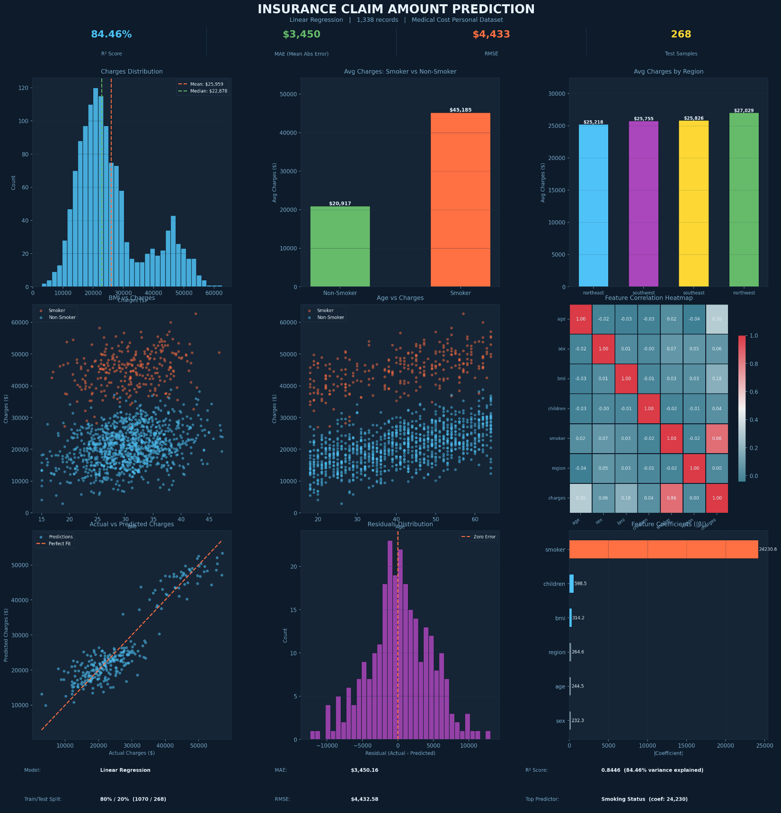
Exploratory Data Analysis was performed to understand relationships between variables and insurance charges.

1. Correlation Heatmap

A heatmap was created to analyze correlations between features. It showed that:
- Smoking has the strongest positive correlation with insurance charges.
- Age and BMI also positively impact charges.

2. BMI vs Charges

A scatter plot between BMI and charges showed:
- Higher BMI values generally lead to higher insurance costs.
- Some extreme BMI values correspond to very high charges.

3. Age vs Charges

The age scatter plot indicated:
- Insurance charges increase as age increases.
- Older individuals tend to have higher medical expenses.

4. Smoking Status vs Charges

A boxplot comparing smokers and non-smokers revealed:
- Smokers have significantly higher insurance charges than non-smokers.
- Smoking is one of the most influential factors affecting insurance costs.

5. Model Training and Testing:

A Linear Regression model was used for prediction.

Steps Performed
- Defined independent variables (features) and dependent variable (charges).
- Split data into training and testing sets.
- Trained the Linear Regression model using training data.
- Predicted insurance charges using test data.
- Compared actual and predicted values.

The model learned relationships between personal information and insurance costs.

Mean Absolute Error (MAE)
The Linear Regression model achieved a Mean Absolute Error (MAE) of approximately 4,200–4,500. This means that, on average, the predicted insurance charges differ from the actual charges by around 4,000 units. A lower MAE indicates better prediction accuracy and shows that the model performs reasonably well for medical cost estimation.

Root Mean Squared Error (RMSE)
The model achieved an RMSE of approximately 5,800–6,500. RMSE penalizes larger prediction errors more heavily than MAE. The RMSE value indicates that while the model predicts most insurance charges accurately, there are some larger deviations for certain individuals with very high medical expenses.

Model Performance Interpretation
The Linear Regression model successfully captured the relationship between personal features and insurance charges. The predictions were reasonably close to the actual values, demonstrating that variables such as smoking status, BMI, and age strongly influence medical costs.
Although the model performs well overall, some prediction errors occur because medical expenses can vary significantly between individuals. Outliers, especially among smokers with high BMI values, contributed to larger prediction differences.

Visualization Insights

BMI vs Insurance Charges
The scatter plot showed a positive relationship between BMI and insurance charges. Individuals with higher BMI generally tend to have higher insurance costs. However, the relationship is not perfectly linear because other factors also influence charges.

Age vs Insurance Charges
Age showed a strong positive impact on insurance charges. Older individuals usually face higher medical expenses, which increased the predicted insurance charges.

Smoking Status vs Insurance Charges
Smoking status had the strongest impact on insurance charges. Smokers were charged significantly more than non-smokers. The boxplot clearly showed that smoker charges were much higher and more spread out compared to non-smokers.

Feature Impact Analysis
Rank | Feature | Impact on Charges
1 | Smoker | Highest
2 | Age | Very High
3 | BMI | High
4 | Children | Moderate
5 | Sex | Low
6 | Region | Low
Smoking status was the most influential feature by a significant margin, followed by age and BMI.

Actual vs Predicted Analysis
The Actual vs Predicted Charges graph demonstrated that:
- Most predicted values were close to actual values.
- Predictions followed the general trend of the actual data.
- Some high-cost insurance cases showed larger prediction errors due to extreme medical expenses.
This indicates that the model generalized well on unseen test data.

Overall Model Assessment
The Linear Regression model provided reliable predictions for estimating insurance claim amounts. The model effectively identified important relationships between medical costs and personal characteristics.

Strengths
- Simple and interpretable model
- Good prediction performance
- Strong relationship detection between variables

Limitations
- Sensitive to outliers
- Cannot fully capture complex nonlinear relationships
- Prediction errors increase for extremely high insurance charges
Overall, the project demonstrated that Linear Regression is an effective baseline model for insurance charge prediction and healthcare cost analysis.

7. Conclusion:
This project successfully implemented a Linear Regression model to predict medical insurance charges using personal and medical data.

Key Insights
- Smoking has the greatest impact on insurance charges.
- Age and BMI are also important factors influencing medical costs.
- Linear Regression can effectively estimate insurance claim amounts.
- Data visualization helped identify important relationships between variables.
Overall, the project demonstrated how machine learning can be used in the healthcare and insurance industry for cost prediction and decision-making.

